Summer Wellness Activity 2023 Move It Challenge
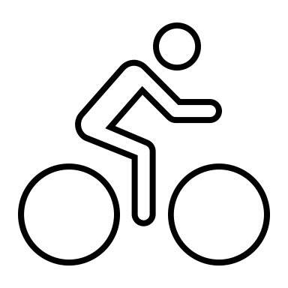
This challenge is designed to get you up and MOVING and possibly to try new things that you just might like and incorporate into your fitness routine. Complete the assigned tasks listed below in one of the months listed, by marking which activity you complete. You must complete 20 activities listed to complete the challenge.

Name: ____________________
Department: _______________

Month: June July August (circle one)

Work out at a Fitness Center for at least 10 min | Go on a 10 min walk outside | Use an indoor or outdoor walking path/trail | Try out a new exercise | Do an outdoor activity
Go on a 20 min walk | Do stretches | Get up off the couch during commercial breaks and do squats | Do 25 bicep curls using any kind of weights (soup cans, milk, weights, etc.) | Get outside for at least 10 min each day for an entire week
Do stretches | Walk a pet for 10 min | Go for a bike ride | Do 20 jumping jacks | Use an indoor or outdoor walking path/trail
Have a dance party | Try out a new exercise | Do 10 burpees | Do a 1 min plank | Go on a 10 min walk
Do a 1 min wall sit | Do yoga for 15 min | Go on a 20 min walk | Do 20 sit-ups | Do 15 push-ups

Please submit your completed form to the Staff in the Rec Center or email to recc@larsondoors.com by September 8th, 2023, for the chance to win a prize.

